Chapter 4

System Design

The purpose of the design phase is to develop a clear understanding of what the developer wants people to gain from his/her project. As the developer works on the project, the test for every design decision should be "Does this feature fulfil the ultimate purpose of the project?"

A purpose statement affects the design process by explaining what the developer wants the project to do, rather than describing the project itself. The Design Document will verify that the current design meets all of the explicit requirements contained in the system model as well as the implicit requirements desired by the user.

4.1 Structure of Design Document

1. **Entity Relationship Diagram** –

An entity-relationship model (or ER model) describes interrelated things of interest in a specific domain of knowledge. A basic ER model is composed of entity types (which classify the things of interest) and specifies relationships that can exist between entities (instances of those entity types).

An entity-relationship diagram for an MMORPG using Chen's notation.

In software engineering, an ER model is commonly formed to represent things a business needs to remember in order to perform business processes. Consequently, the ER model becomes an abstract data model, that defines a data or information structure which can be implemented in a database, typically a relational database.

Entity-relationship modelling was developed for database and design by Peter Chen and published in a 1976 paper. However, variants of the idea existed previously. Some ER models show super and subtype entities connected by generalization-specialization relationships, and an ER model can be used also in the specification of domain-specific ontologies.

1. **Schema Diagram –**

In database terms, a schema is the organisation and structure of a database. Both schemas and schemata can be used as plural forms. A schema contains schema objects, which could be tables, columns, data types, views, stored procedures, relationships, primary keys, foreign keys, etc. A database schema can be represented in a visual diagram, which shows the database objects and their relationship with each other.

1. **System Architecture –**

A system architecture or systems architecture is the conceptual model that defines the structure, behaviour, and more views of a system. An architecture description is a formal description and representation of a system, organized in a way that supports reasoning about the structures and behaviours of the system.

4.2 Entity Relationship Diagram

This relationship diagram shows how the tables in the database are connected to each other and how the control flows from one table to another when some action is triggered by the user. It also shows the constraints on the database such as primary key constraints, foreign key constraints and procedures and triggers. Entity Relationship Diagram is also called an ER Diagram.

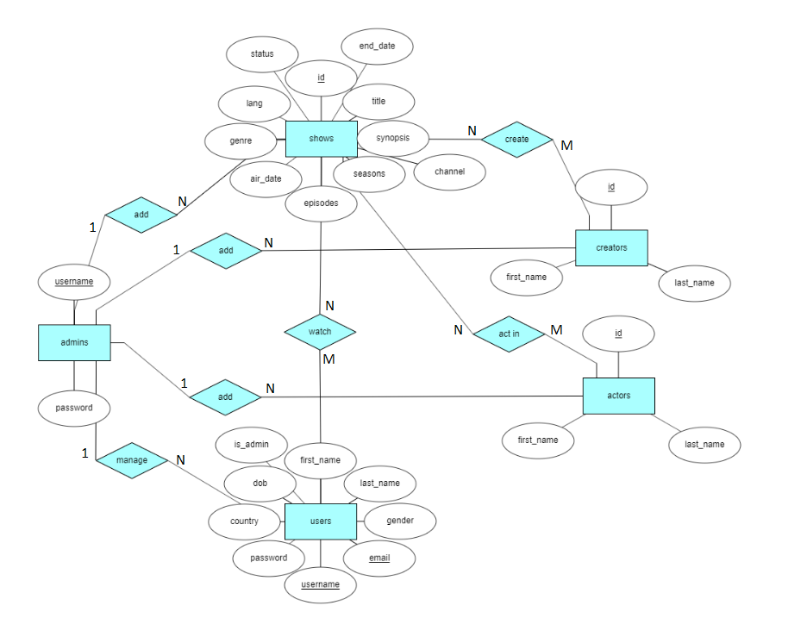

Figure 4.1 – Entity Relationship Diagram

4.3 Schema Diagram

The Schema Diagram gives us information about the attributes in the table of the database and how the given tables are related to each other.

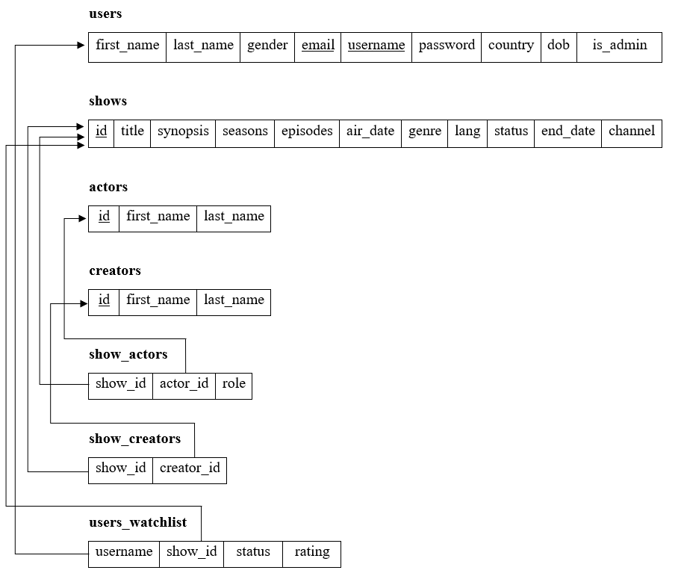

Figure 4.2 – Schema Diagram

4.4 Creating a Database

Once we start the Apache Server and the MySQL Server, the next step is using MySQL and creating a database and table which will hold information to be used by Let’s Watch. The XAMPP package contains an application called phpMyAdmin which allows developers to administer and maintain MySQL databases. We will be using phpMyAdmin to create a database and table, and enter test data. Before testing phpMyAdmin, make sure that both Apache and MySQL are running by opening their respective batch files: apache_start.bat and mysql_start.bat. After Apache and MySQL are running in the background, we navigate to **http://localhost/phpmyadmin/** using a web browser.

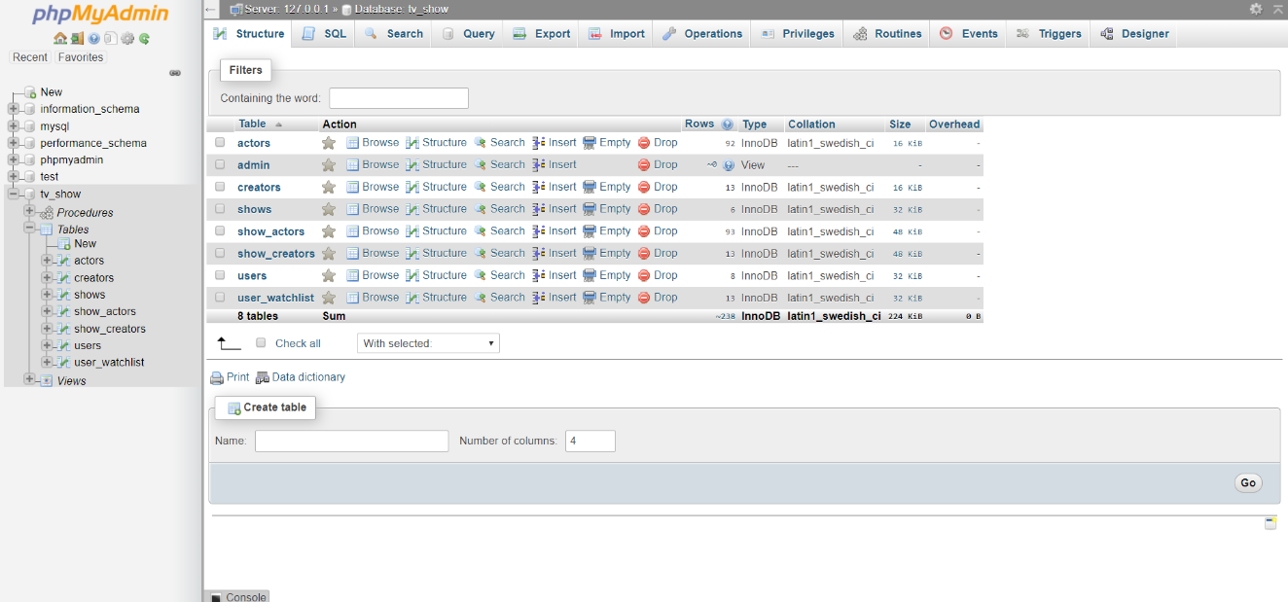

Figure 4.3 – PHPMyAdmin showing all Tables

The above picture shows how exactly the phpMyAdmin page looks like. All the SQL commands can be executed here.

4.5 Table Design

1. **Users Table Design**

The users table consists of details of all the users of the Let’s Watch Program. The schema of the users table is as shown below.

|  |  |  |  |  |  |  |  |  |
| --- | --- | --- | --- | --- | --- | --- | --- | --- |
| first_name | last_name | gender | email | username | password | country | dob | is_admin |

1. first_name is the First Name of the user. It is of type varchar.
2. last_name is the Last Name of the user. It is of type varchar.
3. gender is the Gender of the user. It is of type int. The gender of the user is stored as 0 for male, 1 for female and 2 for others.
4. email is the Email of the user. It is of type varchar. It is a primary key of this table. Hence, there can only be one user with a unique email.
5. username is the login id of the user. It is of type varchar. It is a primary key of this table. Hence, no two users can have the same username.
6. password is the Password used by the user to log into the application. It is of type varchar.
7. country is the Country in which the user resides. It is of type varchar.
8. dob is the user’s date of birth. It is of type date.
9. is_admin is the status of the user. It is of type int. Here, 0 represents that the user is not an admin of Let’s watch whereas 1 represents that the user is an admin of Let’s Watch.
10. **Shows Table Design**

The shows table consists of details of all the shows present in the Let’s Watch Program. The schema of the shows table is as shown below.

|  |  |  |  |  |  |  |  |  |  |  |
| --- | --- | --- | --- | --- | --- | --- | --- | --- | --- | --- |
| id | title | synopsis | seasons | episodes | air_date | genre | lang | status | end_date | channel |

1. id is an identification number given to every show. It is of type int and is auto-incremented. It is the primary key of the table. Hence, each show is uniquely identified by its id.
2. title is the Title of the Television Show. It is of type varchar.
3. synopsis is the Description of the plot of the Television Show. It is of type varchar.
4. seasons is the number of seasons the show has completed. It is of type int.
5. episodes is the number of episodes aired in the Television Show. It is of type int.
6. air_date is the date on which the first episode of the Television Show aired. It is of type date.
7. genre is the Genre of the Television Show. It is of type varchar.
8. lang is the Language of the Television Show. It is of type varchar.
9. status represents the Status of the Television Show. It is of type int. Here, 0 represents that the show is Still Running, whereas 1 represents that it has ended.
10. end_date is the date of the last episode of the Television show. It is of type date.
11. channel is the channel on which the television show is broadcasted. It is of type varchar.
12. **Actors Table Design**

The actors table consists of the names of the actors. The schema of the actors table is as shown below.

|  |  |  |
| --- | --- | --- |
| id | first_name | last_name |

1. id is the identification number given to an actor. It is of type int. It is the primary key of the table and is auto-incremented. Hence, the id uniquely identifies an actor.
2. first_name is the First Name of the Actor. It is of type varchar.
3. last_name is the Last Name of the Actor. It is of type varchar.
4. **Creators Table Design**

The creators table consists of the names of the creators. The schema of the creators table is as shown below.

|  |  |  |
| --- | --- | --- |
| id | first_name | last_name |

1. id is the identification number given to a creator. It is of type int. It is the primary key of the table and is auto-incremented. Hence, the id uniquely identifies a creator.
2. first_name is the First Name of the Creator. It is of type varchar.
3. last_name is the Last Name of the Creator. It is of type varchar.
4. **show_actors Table Design**

The show_actors table maps the actors and the shows in which they have acted in. The schema of the show_actors table is as shown below.

|  |  |  |
| --- | --- | --- |
| show_id | actor_id | role |

1. show_id represents the Id Number of the show. It is a foreign key to the table. It references the id attribute in the shows table. It is of type int.
2. actor_id represents the Id Number of the actor. It is a foreign key to the table. It references the id attribute in the actors table. It is of type int.
3. role represents the Name of the Character played by the Actor in a particular show. It is of type varchar.
4. **show_creators Table Design**

The show_creators table maps the creators and the shows they have created. The schema of the show_creators table is as shown below.

|  |  |
| --- | --- |
| show_id | creator_id |

1. show_id represents the Id Number of the show. It is a foreign key to the table. It references the id attribute in the shows table. It is of type int.
2. creator_id represents the Id Number of the creator. It is a foreign key to the table. It references the id attribute in the creators table. It is of type int.
3. **users_watchlist Table Design**

The users_watchlist table records the shows watched by the users. The schema of the users_watchlist table is as shown below.

|  |  |  |  |
| --- | --- | --- | --- |
| username | show_id | status | rating |

1. username represents the username of the User. It is a foreign key to the table. It references the username attribute in the users table. It is of type varchar.
2. show_id represents the Id Number of the show. It is a foreign key to the table. It references the id attribute in the shows table. It is of type int.
3. status represents the status of the show to the user. It is of type int. Here, 0 represents that the user has not yet started to watch the show, i.e., it is in his/hers watchlist, 1 represents that the user is currently watching the show and 2 represents that the user has completed watching the show.
4. rating is the Rating provided by the user to the show after he has completed watching it.

4.6 Views

This Project consists of one view called admins derived from the users table. The admin table contains the username and password of those users who have admin status.